**Jmeter Load Testing Error and Cluster Setup**

**Error:** JTL file not getting overwritten and problem in local setup.

**Actions Taken to Solve the Error:**

1. Removed JTL file and reran the JTL command.
2. Ensured the Apdex score in the report is close to 1.
3. Scaled the following services:
   * OPD Service: 5 replicas
   * Identity Service: 3 replicas
   * Master Service: 3 replicas
4. Reduced memory allocation of OPD service as it is running 5 replicas.
5. **Setting up JMeter Cluster:**
   * JMeter Cluster Setup:
     + Master 1 & Worker 1 on the same server: 192.168.120.32
     + Worker 2: 192.168.120.37
     + Worker 3: 192.168.120.34
6. From Master, triggered the load testing.
   * Each worker executed **40 threads * 3 loops**, totaling **120 threads * 3 loops**.

**Before Optimization:**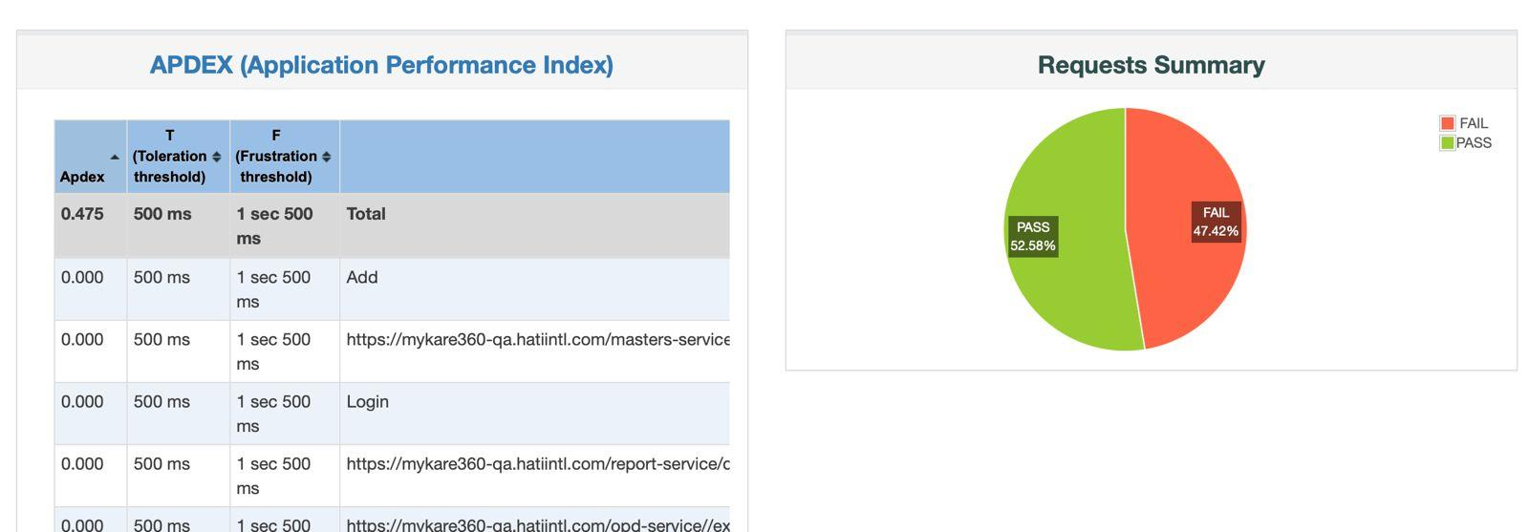

**After Optimization:**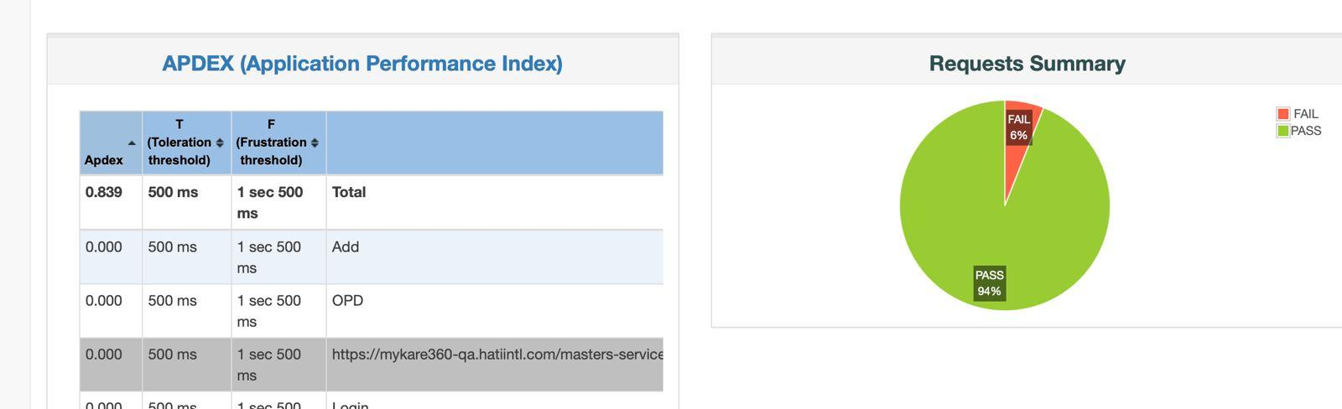

**Setting up JMeter Cluster Steps:  
  
1. Create a Systemd Service File**

**Create a new service file for JMeter:**

**sudo vi /etc/systemd/system/jmeter-server.service**

**[Unit]  
Description=Apache JMeter Server  
After=network.target  
  
[Service]  
User=medcare  
Group=medcare  
WorkingDirectory=/home/medcare/Jmeter/apache-jmeter-5.6.3/bin  
ExecStart=/home/medcare/Jmeter/apache-jmeter-5.6.3/bin/jmeter-server  
Restart=always  
LimitNOFILE=65536  
  
[Install]  
WantedBy=multi-user.target**

**2. Reload Systemd and Enable Service**

**Run the following commands to reload the service files:**

**sudo systemctl daemon-reload  
sudo systemctl enable jmeter-server  
sudo systemctl start jmeter-server**

**3. Verify the Service Status**

**Check if JMeter Server is running:**

**sudo systemctl status jmeter-server**